**Task – 06/12/19**

**Word:** Justin Trudeau

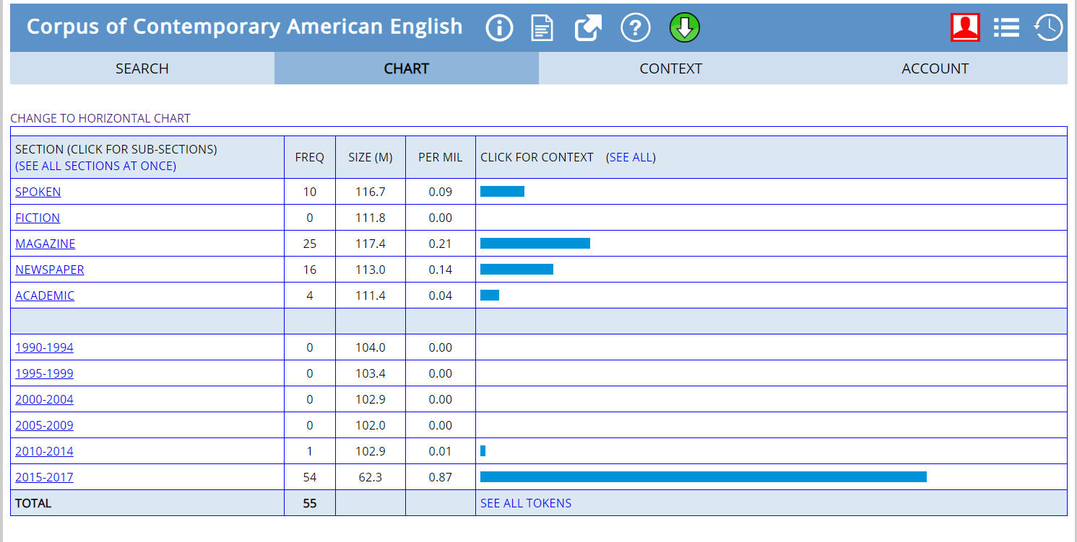

**Year popular: 2015 – 2017**

**Reason:** He was spoken about a lot during this period for his various activities as Prime Minister of Canada. He was spoken for his talk on terrorism, trade agreement with the U.S, and for winning the Canadian general elections in the year 2015.

**Word:** Republican

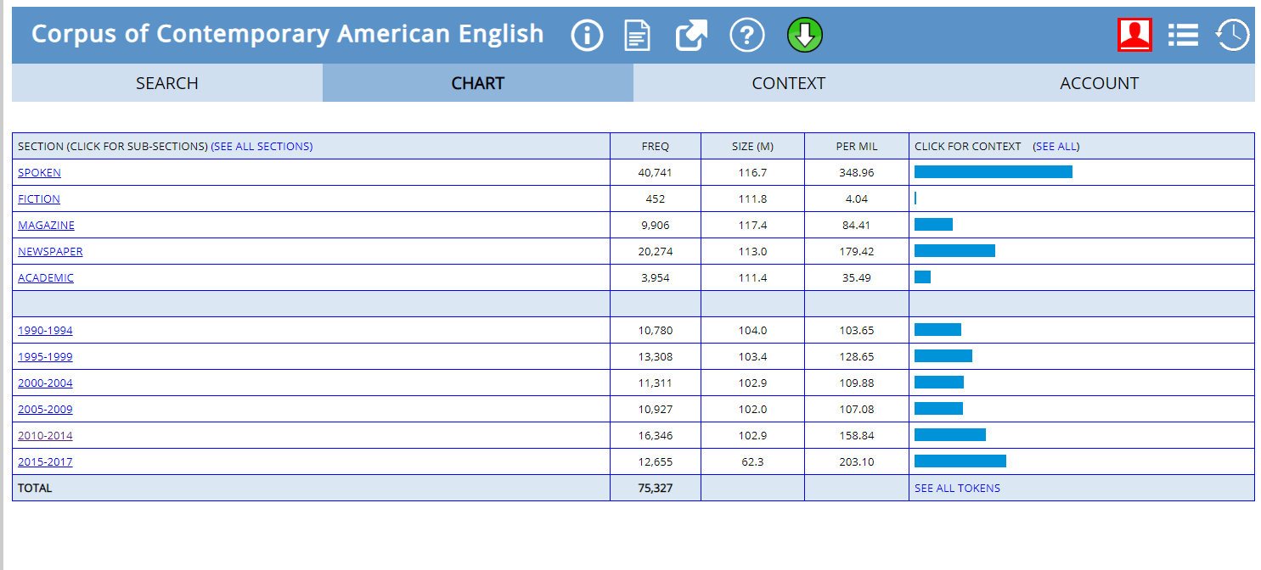

**Year popular: 2010 – 2014**

**Reason:** The word Republican was used many times referring to the republican party in U.S. The were mentioned for many reasons like, injury of old chairman, Priebus won the party election and became its new chairman, a party member attending tea party with the congressmen.

**Word:** Climate Change

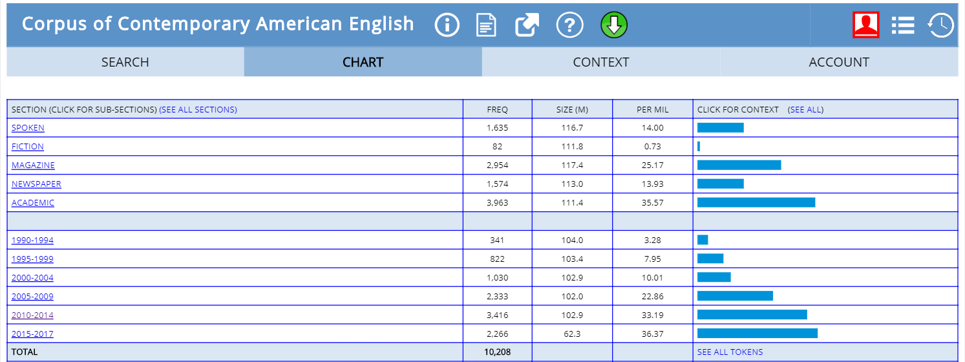

**Year popular: 2015 – 2017**

**Reason:** Reason for the popularity of the term climate change during this period is due to President Donald Trump addressing to the climate change and having talks with activist Al Gore, actor Leonardo Di Caprio and former vice president of U.S also spoke about climate change. Paris agreement on climate change is also spoken about.

**Word:** Extinct

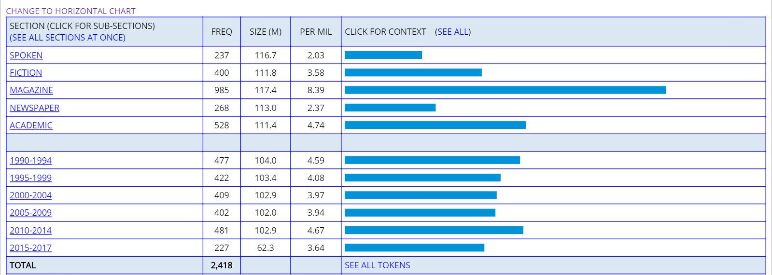

**Year popular: 2010 – 2014**

**Reason:** Talks about animals that has gone extinct, like sint holo, scillifolia. Towns that has gone extinct. Even dangers of many more wild life going extinct if we continue living this way has been discussed.

**Word:** Amazon

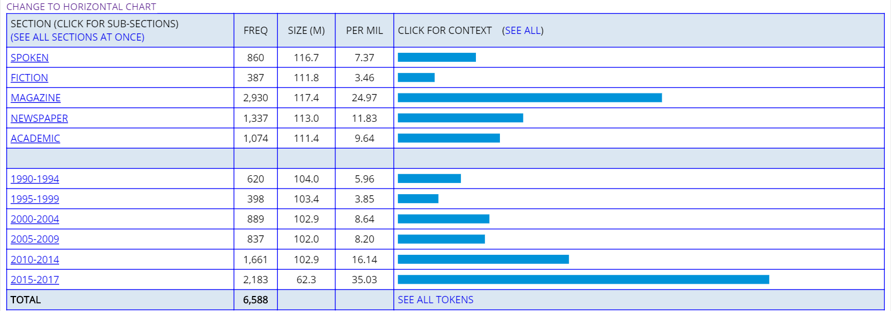

**Year popular: 2015 – 2017**

**Reason:** During this time E-commerce site Amazon was the one which was most referred. Topics like prime day offer, product reviews, product advertisements were mentioned.

**Home Work**

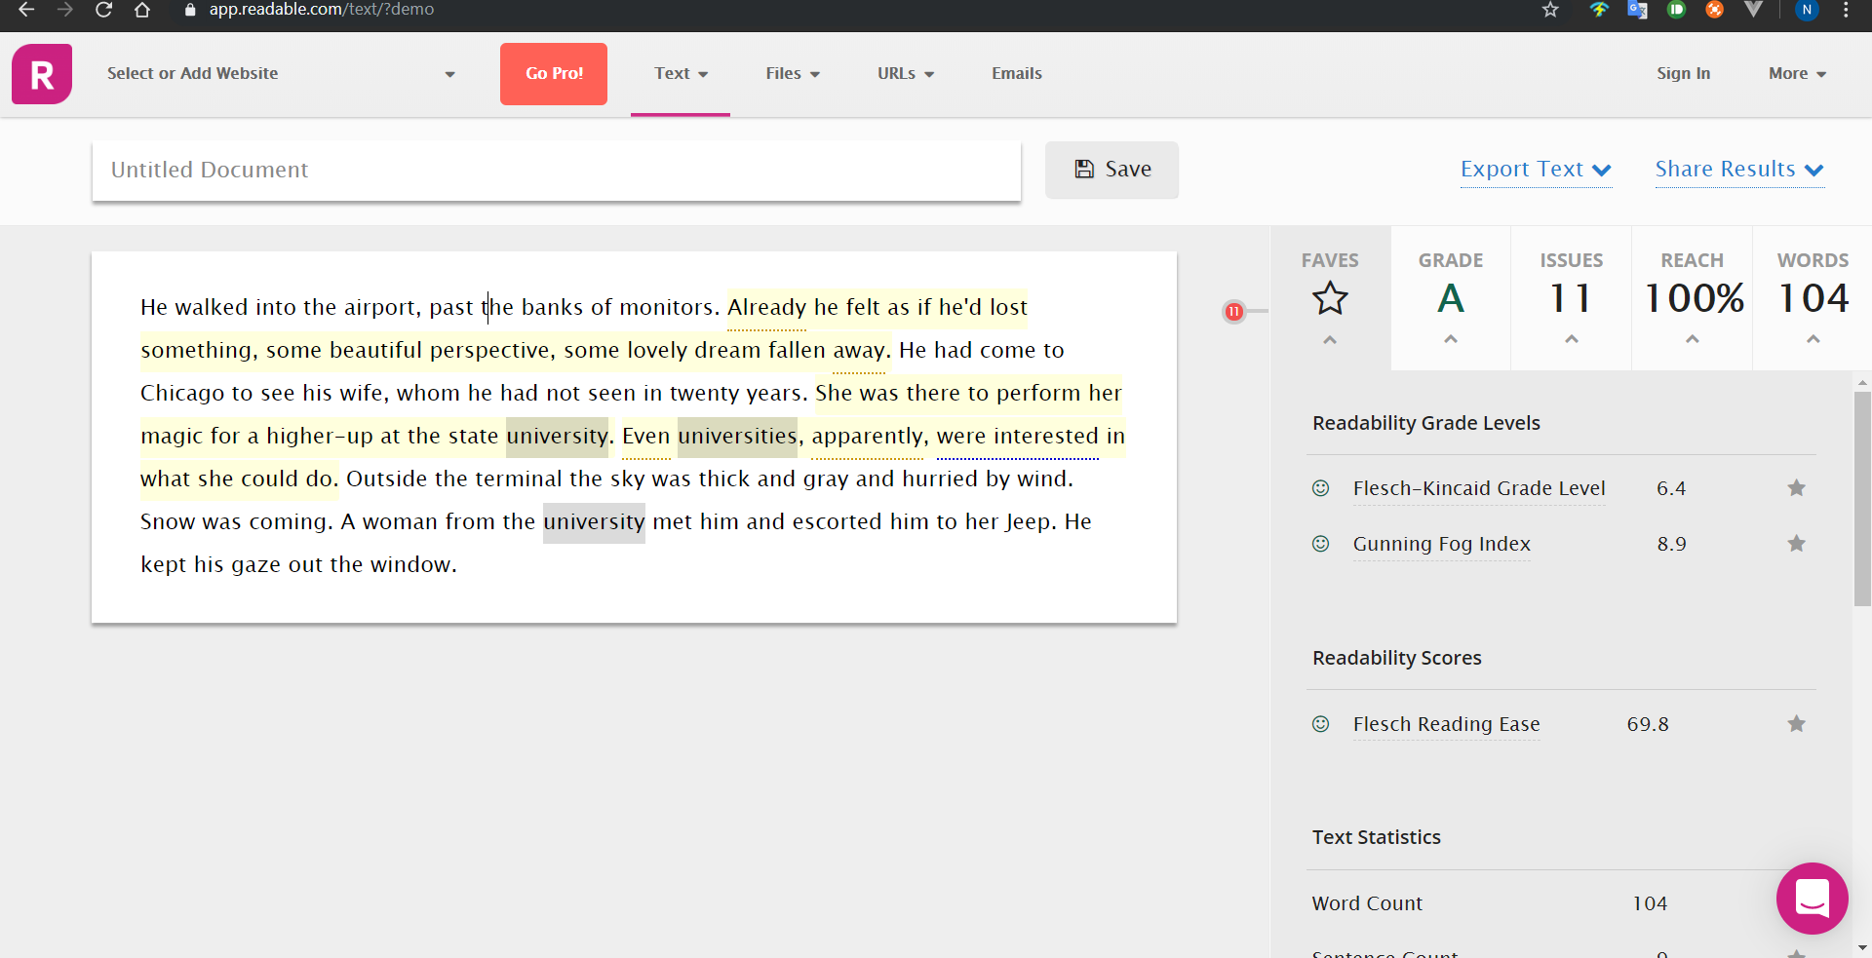

I found out that there are various measures to find out the readability index of a give text. Different parameters such as Flesch-Kincaid Grade level, Gunning Fox Index, Flesch Reading Ease, grammar, sentence length, sentence complexity, word complexity.

A higher readability score to the given text means the text is highly readable and it can be better understood.